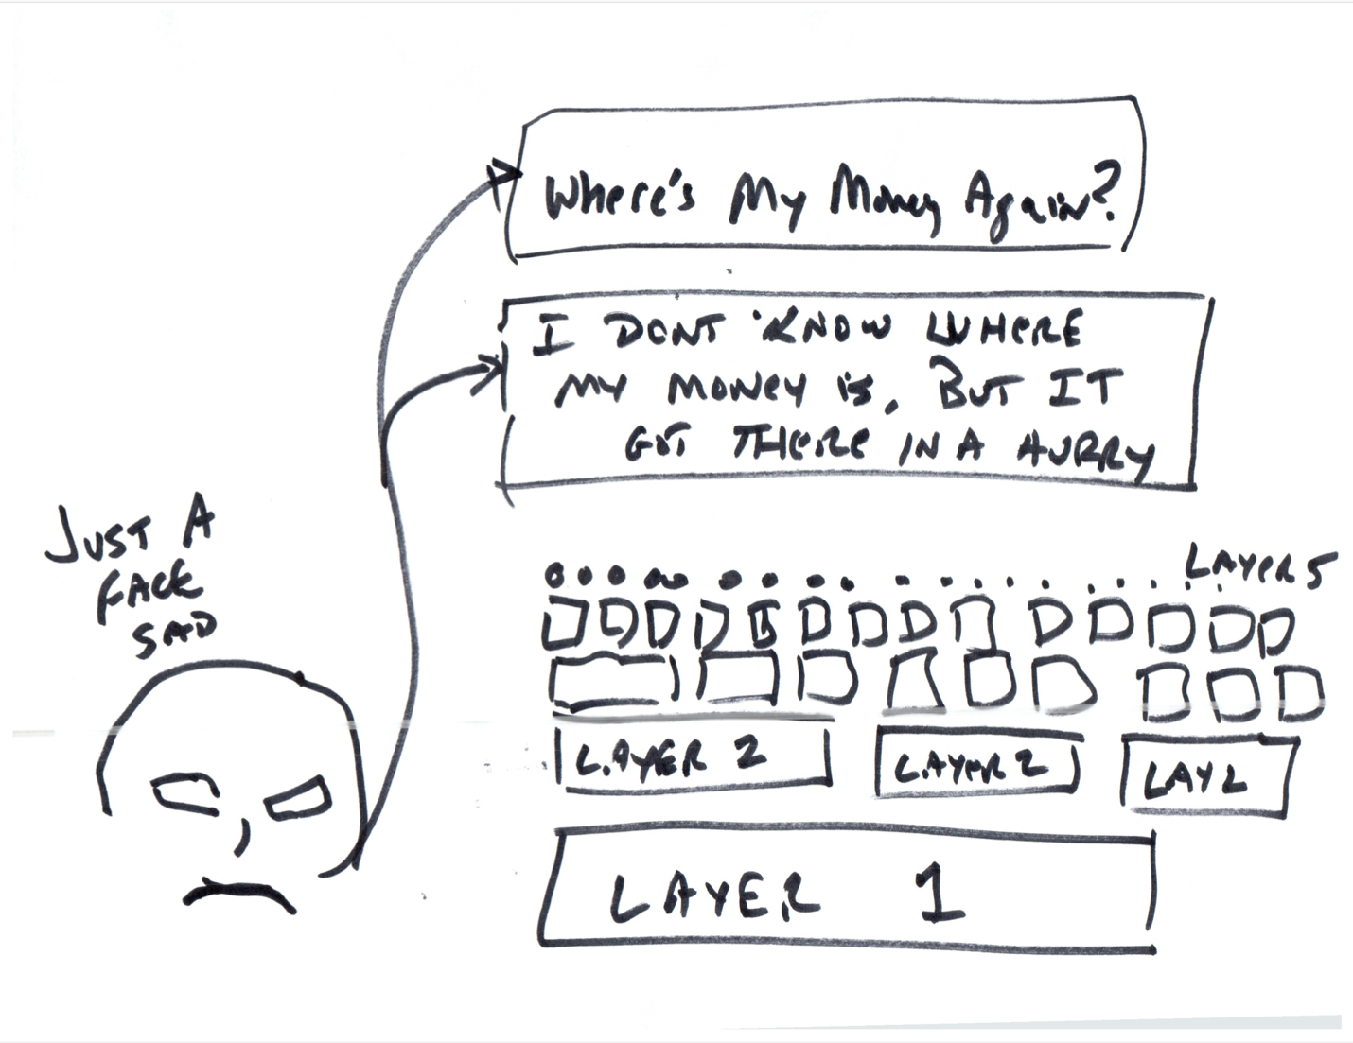

Many people think that in order to scale to a worldwide level, Etheruem (and other blockchains) will have to build out what are called Layer Twos. (That’s the plural. A single layer is called a “Layer 2”).

What those people are proposing could be correct, but what they are missing is that each time a ‘regular person’ such as myself interacts with a new layer 2 I have the same exact problems I have with Layer 1. I can’t figure out where my money is. (See the Bob Crachett image.)

(Layer 2s are frequently the same software as Layer 1 but with modifications to make it faster while trading off some of the security provided by Layer 1).

This image plays off the question – What happens when we figure out that Layer 2s are not fast enough? We build Layer 3 of course, then Layer 4, 5, 6 ad infinitum…

I envision this image as just a person’s face in the lower left corner. That person is (in my mind) a youngish person (maybe long, blonde hair – sort of a California surfer dude, like Stuart for “The Californians” see below) person who’s already bought in to the entire growingly complex structure that rises above him saying something like “I don’t know where my money is, but boy did it get there quickly…”

This is Stuart from The Californians:



The facial expression is wrong, but this is the vibe for the ‘face’ in the corner.